Library Schedule – 2C Classes

Wednesday, 9/14/2016
Friday, 9/23/2016
Wednesday, 9/28/2016
Wednesday, 10/12/2016
Friday, 10/21/2016
Wednesday, 10/26
Wednesday, 11/9/2016
Friday, 11/11/2016
Wednesday, 12/7/2016
Wednesday, 12/21/2016
Wednesday, 1/11/2017
Wednesday, 1/25/2017
Wednesday, 2/8/2017
Wednesday, 2/22/2017
Wednesday, 3/8/2017
Wednesday, 3/22/2017
Wednesday, 4/12/2017
Friday, 4/21/2017
Wednesday, 4/26/2017
Wednesday, 5/10/2017
Wednesday, 5/24/2017
Wednesday, 6/7/2017

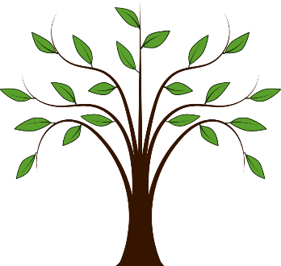
Reading helps us grow!

