1. 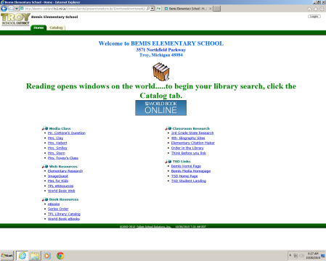Log in using your TSD username and password.
2. Click on Follett Shelf.

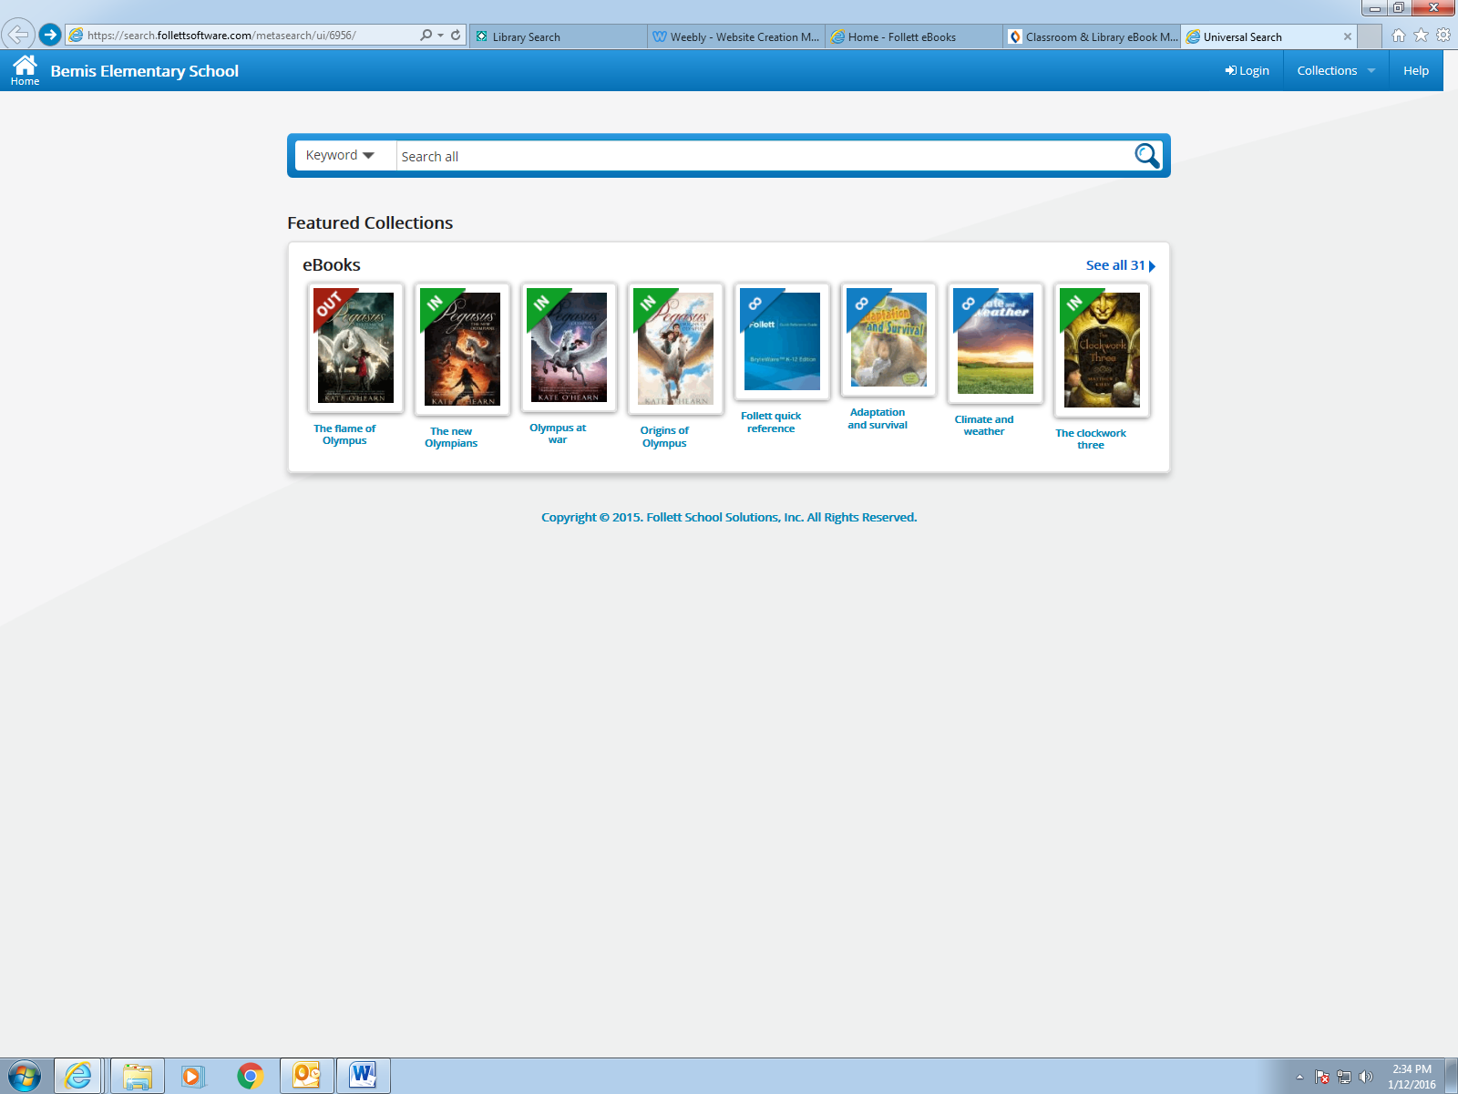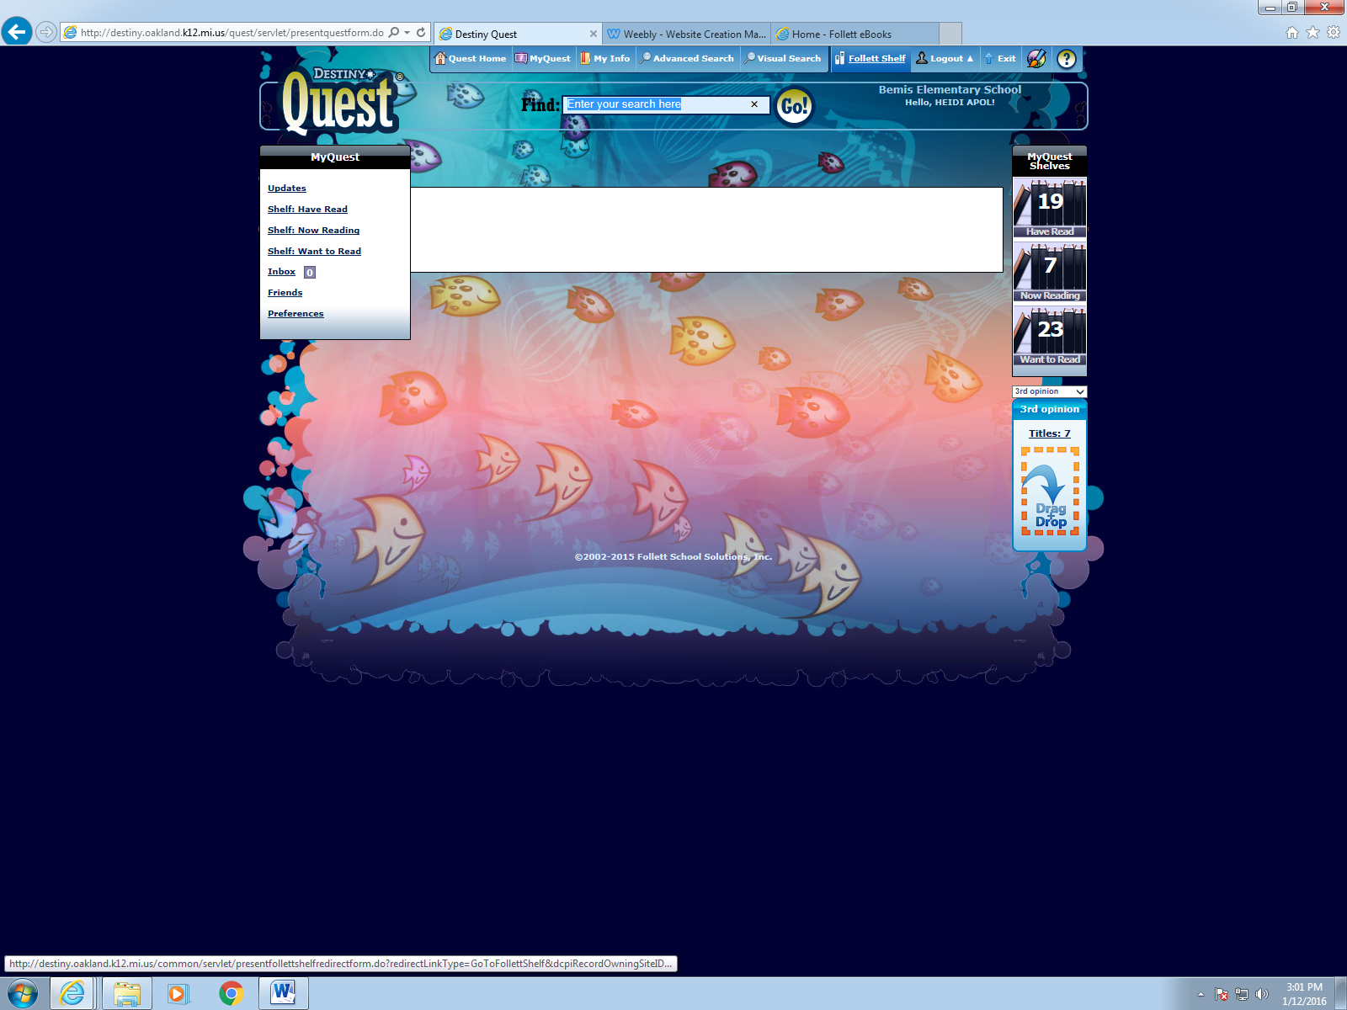

1. Click on a book to open it or check it out. Enjoy!